October 2021
Important Dates:
Staff Training: 1st and 2nd November
Term begins for students on 3rd November

Half Term Focus
This Half Term we have re-written the Student Agreement to give students ownership of their own choices. We discussed how students would like to feel whilst in school and how to help each other to achieve this atmosphere.
Students are engaging well with the Trackers and we can see how putting the boundaries in place in agreement with the students is enabling them to make positive choices and understanding why.
Daily Emotion Check Ins and Check Outs are helping all students to feel safe, loved and understood.
Students are learning the skills of self and co-regulation with their Keyworkers.
We have a new sensory area in our Wellbeing Room, in which regular mentoring sessions will take place including Hand Massages, Meditations, Breathing and Mindfulness.

Plato News:

Students have been getting their hands messy in clay by creating some fab Graffiti names!

Fun times at the farm! Students have helped out with the horses and the rabbits.

After Online Assessment the students have been working on their Literacy and Numeracy Learning gaps in knowledge and gaining confidence.

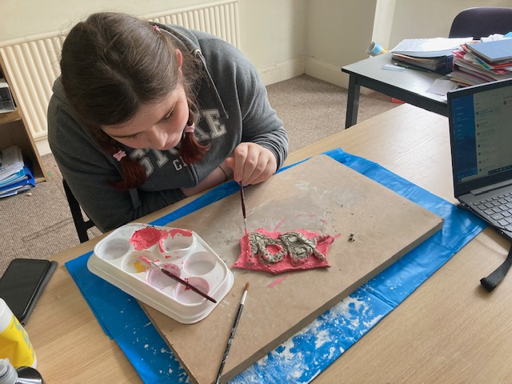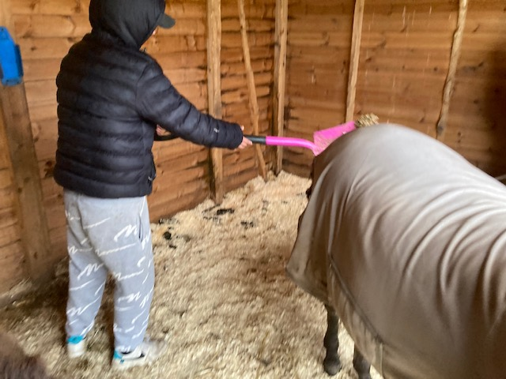

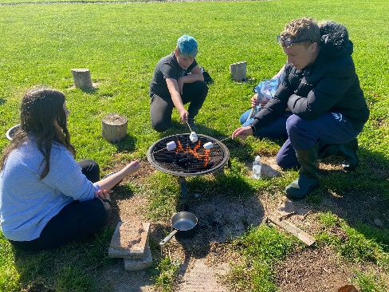
In Creative Studies with Alex the students have created their own designs for costumes. Will and Mia actually repurposed recycled materials to create parts of them ! 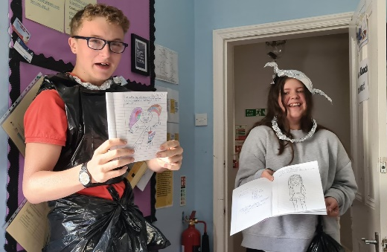

English
The study of literature has now been integrated with the new English and Functional Skills course and students have been enjoying, exploring and discussing ideas generated by the texts. New books have been ordered for the school library and reading for enjoyment is being integrated into the school day.
In Functional Skills lessons pupils have been exploring instructional texts and have used these skills in a real life setting to safely bring the fish back to their new home in the Wellbeing room.

Personal Enrichment this Half Term has focused on the introduction of weekly swimming lessons, which has seen many pupils pushing themselves out of their comfort zones and into new achievements.
Visits to Westport Lake have been very successful., especially as they have ended with lunch in the café!
Students have made their own lunches, including full English breakfasts, and are practicing making regular brews for staff!
Keep your eyes open for new developments in our garden area and preparations for exciting Christmas celebrations.
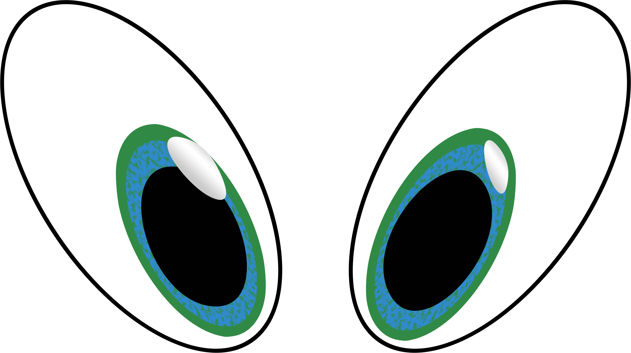

Personal Wellbeing / PSHE

Key stage 3 - Students have been looking at the impact of social media on our wellbeing this term – they have been sharing lots of feelings and thoughts on this subject.

Key stage 4 – Students have continued to work towards their level 1 award in Personal Wellbeing this term. The unit they are completing is Sex and Relationships. The students have shown a very mature attitude around this subject and should be very proud of themselves.

On Thursday 7th October students took part in a Wellbeing Champions morning – where they took part in activities in promoting positive wellbeing

support@diamond-families.

Important Dates:
Staff Training Days: 1st and 2nd November 2021
Term ends for Christmas: 16th December 2021

“Childhood education is a precious time that should be fun and nurturing. It is our mission to empower and inspire learners to enjoy education and seek their own true potential” www.intuitionschool.co.uk 01782315758

 | Website: |  |  |  | Contact: |  |  |  | Email:

