English

Our Half Term Focus was Reading.
Students have engaged in reading comprehension and interventions where they have read stories aloud.

WHODUNNIT????

When students arrived back this year there had been a murder in the classroom!! Victor Frankenstein was the victim.
Throughout the English lessons students had clues and researched the history of the suspects. They wrote a newspaper report on the story and were encouraged to use persuasive techniques and language and constructing their investigations.
The crime was solved by all, and the murderer was …….

Mrs. Johnstone!!!!

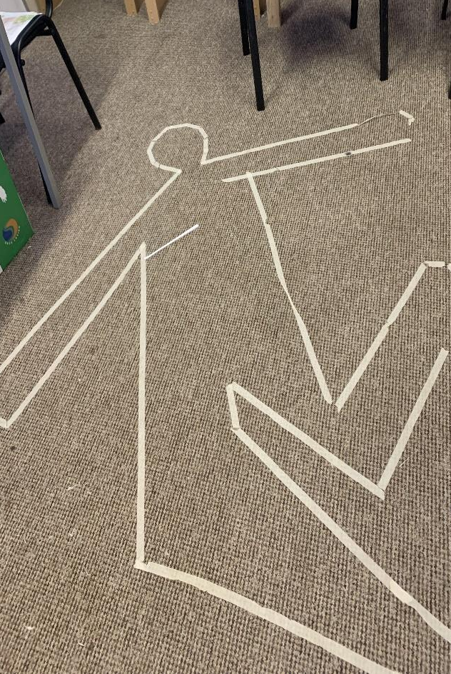
This Term Focus
This Half Term we introduced our brand-new uniform. The students look really smart and have said they find the uniform warm and comfy. We hope to see more students wearing it next term.
If each student wears full uniform for 80% of his/her expected time onsite at school, they will be rewarded with an event of their choice

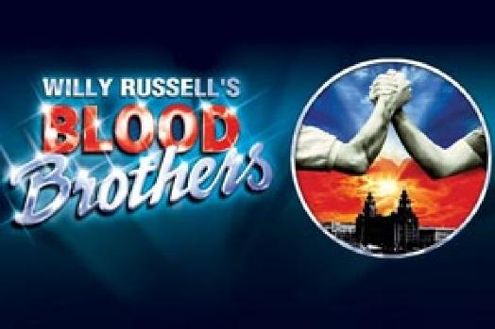
On Thursday 17th February. We went to see Blood Brothers - The Musical - at The Palace Theatre, Manchester, which will be the text we are looking at in English next term.
We took the students for lunch beforehand.

Blood Brothers, a musical by Liverpudlian playwright Willy Russell, revolves around twin boys (Mickey and Edward) who are separated at birth and brought up in completely different environments in the city.
There were lots of twists and turns throughout the play, lots of giggling from the students. The play itself promised to be an emotional rollercoaster .... which it was - we laughed lots in the first half, but then the ending had us in tears (especially the staff).

Students represented the school impeccably from beginning to end with exceptional manners and a very mature attitude.
We can’t wait to go on another trip.

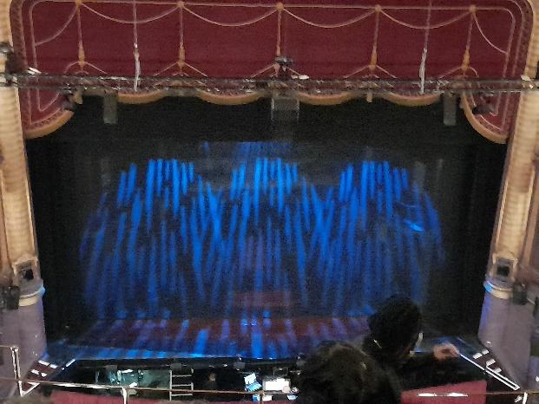

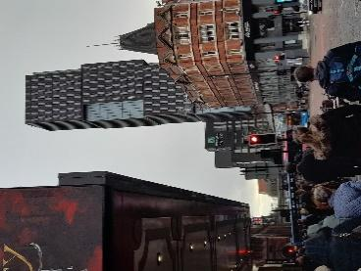

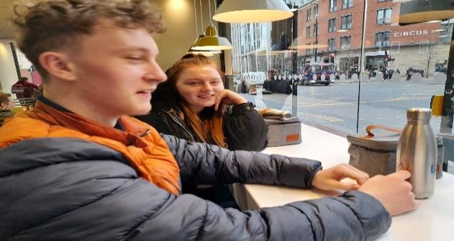
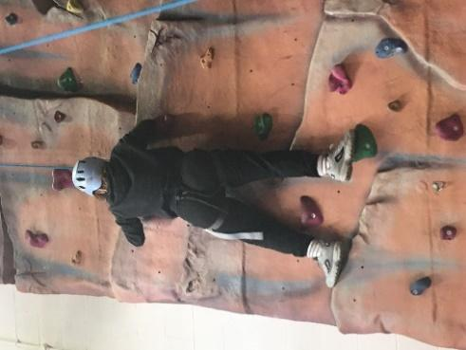

Personal Wellbeing / PSHE

This term we have taken part in Safer Internet Day 2022 which was celebrated on 8th February with the theme “All fun and games? - Exploring respect and relationships online”. We also took part in Children’s Mental Health Week 2022 which took place from 7-13 February. This year's theme was Growing Together.
We encouraged students to consider how they have grown and how they can help others to grow.

Physical Education:
Students have been enjoying their PE sessions at the YMCA. Together the students and staff have devised their own version of Dodgeball as they have enjoyed the original game so much. You can see the students enjoyed taking part using the climbing wall during these sessions.

Science

Message from Nicola Science Teacher

I am delighted to be back at Intuition School delivering Science sessions.

All students have made a great start, working towards a new Science qualification. Socrates have been learning about materials and their properties. They tested different materials for "Teddy tents" by applying wind, rain and light. They have set up an experiment to investigate the conditions needed for rusting iron. They also tested out two different brands of nappy to see which was the most absorbent. Aldi won by absorbing a massive 400ml of water!

Meanwhile Aristotle tackled the Global Energy Crisis. They have determined the energy transfers involved in everyday objects. Students designed and built model "Eco homes" using different materials to insulate and clad. They then tested the homes by adding a beaker of hot water and recording the temperature over time. They found a well-insulated roof and tin foil wallpaper kept the water hotter for longer.

Maths:

In Maths students have been ordering and comparing large numbers up to one million.
They have added and subtracted, multiplied, and divided decimals up to two places.
We have also been looking at the properties of shapes and recognizing scales on a map.

This term we have introduced 3 new members of staff to the team:
Amy is the English and Maths teacher.
Sam is a new Learning Coach.
Nicola is teaching Science.
Our fantastic students have welcomed all staff with open arms.

Stay safe and well.
Quick reminder: Our school days begin at 09:30 and end at 15:00.

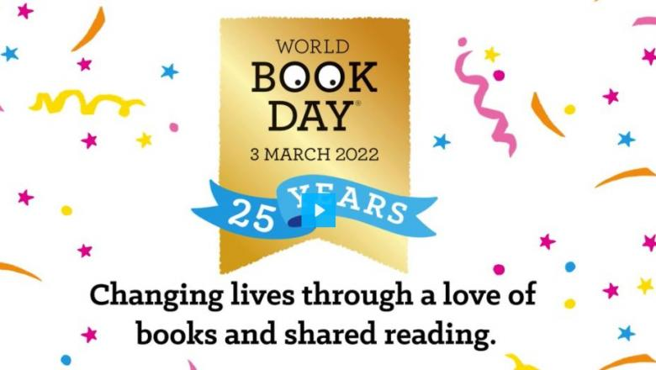
On Thursday 3rd March we will be celebrating World Book Day by:
- decorating the school
- attending Virtual Workshops with authors, including Micheal Rosen.
- baking book themed cupcakes
- listening to 10 minute story shares
- setting up our Book Club, with help from the World Book Day resources
- designing a National Book Token for a Competition

