[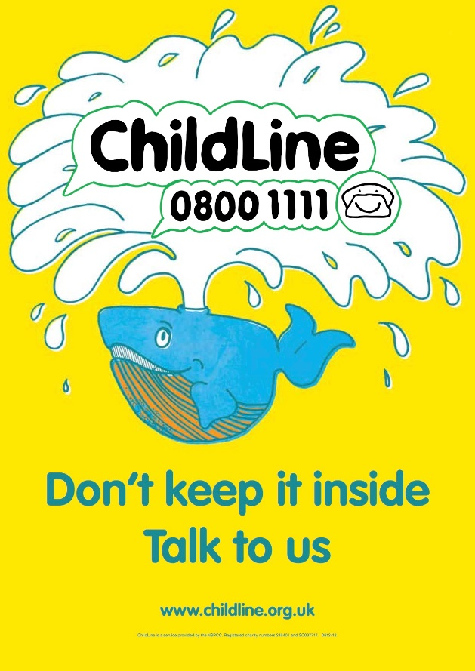](https://www.google.co.uk/url?sa=i&rct=j&q=&esrc=s&source=images&cd=&cad=rja&uact=8&ved=2ahUKEwim5Yy7lrzZAhXGKsAKHUdUAgUQjRx6BAgAEAY&url=https://www.anatomystuff.co.uk/documentrepository/free-bullying-awareness-posters&psig=AOvVaw1kmejNU1v6DRavCibAKzlp&ust=1519480057839379)